Transistor Biasing and Stabilization

Biasing
We known that transistor can operate in any of three regions of operation namely cutoff, active region and saturation. To operate the transistor in these regions the two junction of a transistor should be forward or reversed biased as shown in table
Region of operation | Base Emitter Junction | Collector base junction | Application
Cut off | Reversed bias | Reversed bias | As a switch
Active | Forward bias | Reversed bias | Amplifier
Saturation | Forward bias | Forward bias | As a switch
In order to do so, we need to connect external DC power supplies with correct polarities & magnitude. This process is called as biasing of transistor.

Voltage divider bias (VDB)
The most famous circuit based on the emitter-bias prototype is called voltage divider bias. You can recognize it by the voltage divider in the base circuit.

Accurate VDB Analysis
The Key idea is for the base current to be much smaller than the current through the voltage divider. When the condition is satisfied, the voltage divider holds the base voltage almost constant and equal to the unloaded voltage out of the voltage divider. This Produces a solid Q point under all operating conditions

VDB load line & Q point
The load line is drawn through saturation and cut off. The Q point lies on the load line with the exact location determined by the biasing. Large variations in current gain have almost no effect on the Q point because this type of bias sets up a constant value of emitter current.

Two –Supply emitter bias
This design uses two power supplies: one positive and the other negative . The idea to set up a constant value of „emitter current‟.

Other types of bias
This section introduced negative feedback, a phenomenon that exits when an increase in an output quantity , produces decreases in an input quantity. It is brillent idea that led to voltage-divider bias. The other type of bias cannot use enough –ve feedback, so they fail to attain the performance level to voltage- divider bias.

PNP Transistors
These pnp devices have all current & voltages reversed from their npn counterparts. They may be used with negative power supplies; more commonly, they are used with +ve power supplies in an upside-down configuration.

Reverse Feedback ratio
If some percentage of an amplifier‟s output signal is connected to the input, so that the amplifier amplifies part of its own output signal, we have what is known as feedback. Feedback comes in two varieties: positive (also called regenerative), and negative (also called degenerative). Positive feedback reinforces the direction of an amplifier‟s output voltage change, while negative feedback does just the opposite.

Input & Output impedances
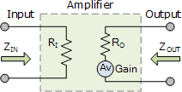
It is the input impedance “seen” by the source driving the input of the amplifier. Z_{in} or Input Resistance is an important parameter in the design of a transistor amplifier and as such allows amplifiers to be characterized according to their effective input and output impedances as well as their power and current ratings.
For details refer to chapter 3

Bias Stabilization
The stability of a system is a measure of the sensitivity of a network to variations in its parameter. Β increases with increase in temperature . Magnitude of V_{BE} decreases about 7.5 mV per degree Celsius (°C) increase in temperature. I_{CO}(reverse saturation current): doubles in value for every 10°C increase in Temperature

Stability Factors, S(I_{CO}), S(V_{BE}), and S(β)
A stability factor,S, is defined for each of the parameters affecting bias stability as listed below: S(I_{CO}) = ΔI_{C} / ΔI_{CO}
S(V_{BE}) = ΔI_{C} / ΔV_{BE} S(β) = ΔI_{C} / Δ β
In each case, the delta symbol signifies change in that quantity.

BJT Transistor modeling
A model is the combination of circuit elements , properly chosen, the best approximates the actual behavior of a semiconductor device under specific operating conditions.
The ac equivalent of a network is
- Setting all dc sources to zero and replacing them by a short- circuit equivalent
- Replacing all capacitors by a short-circuit equivalent.
- Removing all elements bypassed by the short-circuit equivalents introduced by steps 1 & 2.
- Redrawing the network in a more convenient and logical form.

Transistor Model

The T- Model (Ebers- Moll model) The п Model

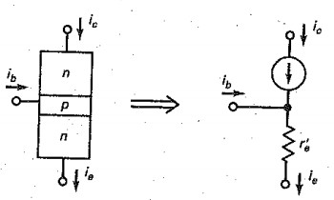
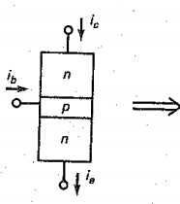
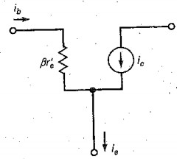

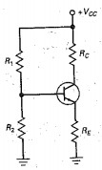
Type | Circuit | Calculations | Characteristics | Where used
Base bias | 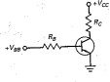 | I_{B}= (V_{BB}-0.7V)/R_{B} I_{C}=βI_{B}  VCE= VCC - ICRC | Few parts; β dependent; fixed base current | Switch; digital
Emitter bias | 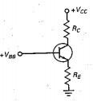 | V_{E}=V_{BB} -0.7V I_{E}= V_{E}/ R_{E} V_{C}= V_{C}-I_{C}R_{C} V_{CE}=V_{C}-V_{E} | Fixed emitter current; β independent | I_{C} driver ; amplifier
Voltage divider bias |  | V_{B}= R₂V_{CC}/(R₁+ R₂)  V_{E}= V_{B}-0.7V I_{E}= V_{E}/ R_{E}  V_{C}= V_{CC}-I_{C}R_{C} V_{CE}= V_{C} - V_{E} | Needs more resistors; β independent; needs only one power supply | Amplifier
Two – supply emitter bias | 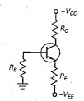 | V_{B} ₌ 0V V_{E}= V_{B}-0.7V V_{RE}=V_{EE}-0.7V  I_{E}=V_{RE}/R_{E} V_{C}= V_{CC}- I_{C}R_{C}  V_{CE}= V_{C}- V_{E} | Needs positive & negative power supplies; β independent; | Amplifier

VDB Derivations

Base voltage Emitter voltage

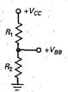
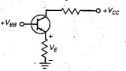
V_{BB}= R₂V_{CC}/(R₁+ R₂) V_{E}= V_{BB}- V_{BE}

Emitter current Collector current

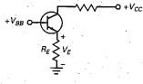
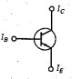
I_{E} = V_{E}/ R_{E} I_{C} ≈ I_{E}

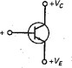
Collector voltage Collector – emitter voltage

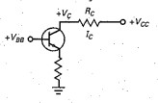
VC = VCC - ICRC VCE= VC - VE

TSEB (Two supply emitter bias) Derivations

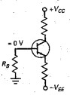
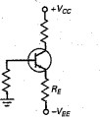
Base voltage Emitter current

V_{B}≈ 0 V_{C}= V_{CC}- I_{C}R_{C}

Collector Voltage (TSEB) Collector-emitter Voltage (TSEB)

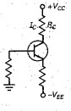
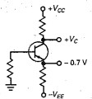
V_{C}=V_{CC} -I_{C}R_{C}
V_{CE}= V_{C}+ 0.7V

Long & Short Questions

What is meant by transistor –biasing ? Define Stability factor.

Or

What do you understand by transistor by transistor biasing ? Why it is necessary ?

Transistor Biasing is the process of setting a transistors DC operating voltage or current conditions to the correct level so that any AC input signal can be amplified correctly by the transistor.

Necessary of transistor biasing
    - To active an transistor, biasing is essential. For proper working it is essential to apply to apply voltages of correct polarity across its two junctions.
    - If it is not biased correctly it would work inefficiently and produce distortion in the output signal
    - Q-point is not middle Output signal is distorted & the signal is clipped
    - Further for various applications , BJT is biased as shown in table

Region of➢opeIration | Base Emitter Junction | Collector base junction | Application
Cut off n | Reversed bias | Reversed bias | As a switch
Active | Forward bias | Reversed bias | Amplifier
Saturation  o | Forward bias | Forward bias | As a switch
In order to have these applications , we need to connect external DC power supplies with correct polarities & magnitude. This process is called as biasing of transistor.

Stability Factor
The stability of Q point of transistor amplifier depends on the following three parameters :
- Leakage current I_{CO} 2. β_{dc} 3. Base to emitter voltage
The effect of these parameters can be expressed mathematically by defining the stability factors
  - Stability factor S = ^{Δ𝐼𝐶}
Δ𝐼𝐶𝑂
Constant V_{BE} & β_{dc}

This represents the change in collector current due to change in reverse saturation current I_{CO} .The other two parameters that means V_{BE} & β_{dc} are assumed to be constant.

  - Stability factor S‟ = ^{Δ𝐼𝐶}
Δ𝑉𝐵𝐸
Constant I_{CO} & β_{dc}

S‟ represents the change in I_{C} due to change in V_{BE} at constant I_{CO} & β_{dc}

  - Stability factor S” = ^{Δ𝐼𝐶}
βdc

Constant I_{CO} & 𝑉_{𝐵𝐸}
Total change in collector current

Δ𝐼_{𝐶}= S. Δ𝐼_{𝐶𝑂} + S‟. Δ𝑉_{𝐵𝐸} + S”. βdc

- Ideally the values of all the stability factors should be zero and practically they should be as small as possible.
- Practically the value of S is significantly higher than the other two stability factor. Hence while comparing the biasing circuits, the values of S is more significant.

What are the various methods used for transistor biasing? Explain one method & State its advantage & disadvantages.
Related Short Answer Questions
(i)
What do you mean by biasing of a transistor ? Explain with examples

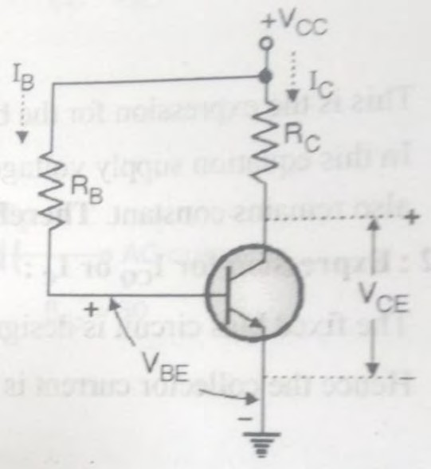
Biasing is a technique to aid V_{BB} in the input circuit which is separate from the V_{CC} used in the output circuit. The following are the most commonly used method for transistor biasing are as below :
- Fixed bias circuit (Single base resistor biasing) or base bias
- Collector to base bias circuit
- Voltage divider bias circuit (VDB) or self bias
- Emitter bias or modified fixed bias circuit Fixed bias circuit (Single base resistor biasing) or base bias The simplest of all biasing is fixed bias ckt. as shown in fig.
- Before biasing we were using two separate power supplies i.e. V_{CC} & V_{BB} to bias a transistor.
- But in this circuit only one power supply has been used to supply power to both collector as well as base.
- R_{B} is the single base biasing resistor , hence this circuit is also called as single base resistor biasing.

Analysis of Fixed bias circuit :

As shown in fig. splitting input & output terminals in two loops , namely base circuit & collector circuit
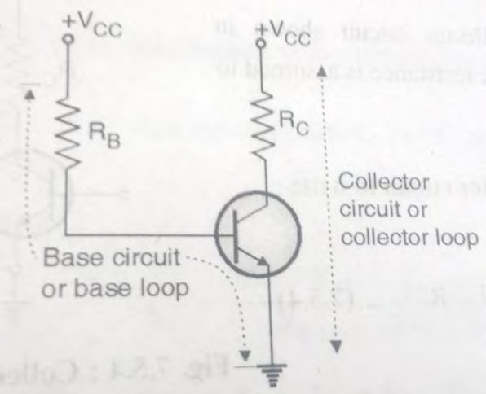
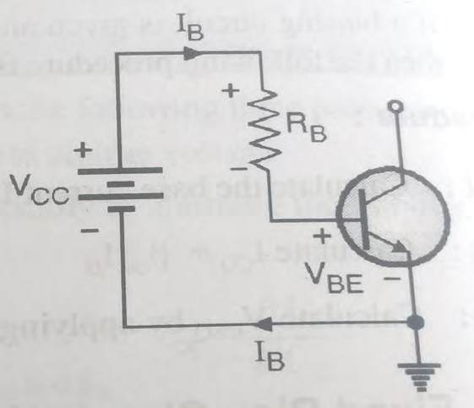
Fig. (a) Fig. (b)

as shown in fig.(a).

Expression for I_{B}
- Consider the base circuit as shown in fig.(b) . Applying KVL to the base circuit we have
- V_{CC} + I_{B}R_{B} + V_{BE} = 0
- Rearranging the equation we get
I_{B} = (V_{CC} – V_{BE})/ R_{B}
- For silicon V_{BE}= 0.7 and for germanium V_{BE}= 0.3V

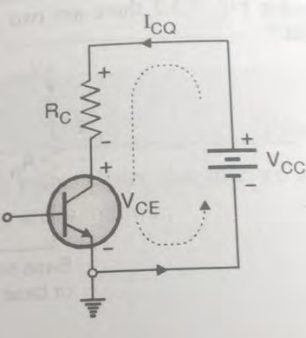
Expression for I_{C} & V_{CE}
Since the fixed bias is operated in the active region therefore I_{C}= β I_{B} + I_{CEO}
∵ β I_{B} >>>I_{CEO}

∴ I_{C}= β I_{B}

Applying KVL to the collector circuit shown , we have V_{CC}- I_{C}R_{C} – V_{CE} = 0
∴ V_{CE} = V_{CC}- I_{C}R_{C}

Advantages

- The fixed bias circuit is simple and less number of components.
- It give very good flexibility as the Q point can be set at any point in the active region by just adjusting the value of R_{B} .

Disadvantages

  - Vary poor thermal stability as S= 1 + β_{dc}.
  - With changes in β_{dc} due to change in temp. , the operating point keeps on shifting its position.

What do you understand by ‘Bias stability’ of a transistor ? Why is it necessary ? Explain the working of self-bias circuit for common emitter BJT.
Or

Draw the circuit diagram of voltage diagram of voltage divider bias of a transistor . Explain its working.
For definition ref. Q.1

Self Bias
The voltage –divider biasing is known as self bias circuit. The circuit for voltage- divider bias is shown in fig. (a) . The resistance R₁ & R₂ form a potential divider to apply a fixed voltage V_{B} to the base.
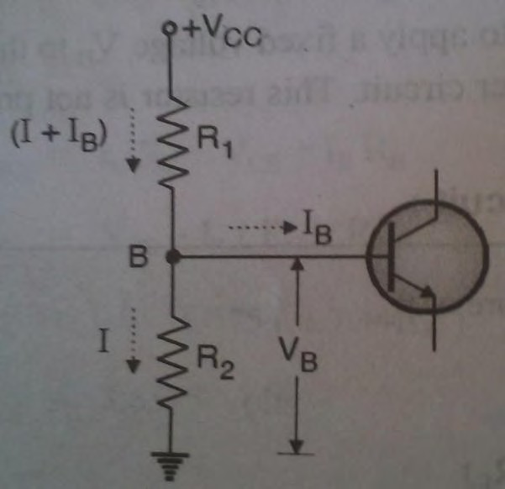
A resistance R_{E} has been connected in the emitter circuit. This resistance is not present in the fixed bias or collector to base bias circuits.
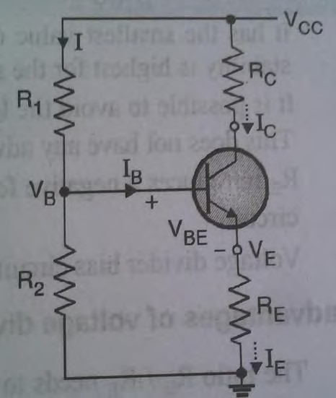

Fig. (a) Fig. (b)

Analysis of Voltage divider bias circuit Base circuit
The base circuit as shown in fig(b) . Here we have considered collector & emitter terminals as open circuited . The base Voltage V_{B} is nothing but the voltage across resistor R₂

i.e. V = ^{𝑅2} 𝑉

B 1 +𝑅2
𝐶𝐶

This is because , current through R₁ & R₂ is approx. same and is equal to I.

Collector circuit

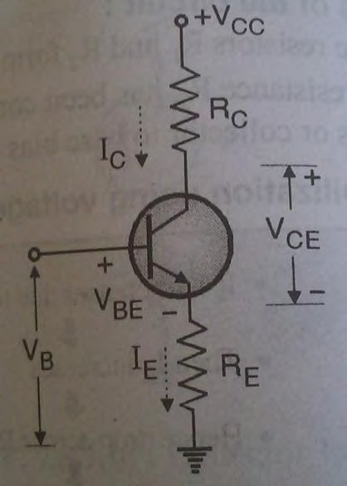
The collector circuit as shown in fig., the voltage across emitter resistance R_{E} can be as follows :
V_{E}= I_{E}R_{E} = V_{B}- V_{BE}

∴ I_{E}= (V_{B}- V_{BE})/ R_{E}

Applying the KVL to the collector circuit we get
-V_{CC} + I_{C}R_{C} + V_{CE}+ I_{E}R_{E}= 0
∴ V_{CC}= I_{C}R_{C} + V_{CE}+ I_{E}R_{E}
V_{CE}= V_{CE} - I_{E}R_{E} -I_{C}R_{C}

Bias stabilization
- If IC increases due to change in temp. or β
- Then IE increases

- Hence drop across RE increases (VE= IERE)
- But VB is constant. Hence VBE decreases.
- Hence IB decreases.

- Hence IC also deceases. Thus the compensation for increase in IC is achived.

Draw the circuit diagram of Collector to base bias of a transistor . Explain its working.

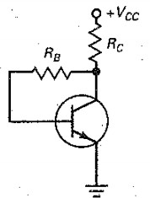
Collector to base bias shown in fig. is also known as collector-feedback bias. Historically , this was another attempt at stabilizing the Q point. Again, the basic idea is to feed back a voltage to the base in an attempt to neutralized any change in collector current.
Like emitter-feedback bias circuit , collector feedback bias circuit uses –ve feedback in an attempt to reduce the original change in collector current.

Analysis
Applying KVL in the base circuit we have

-VCC + RC(IC+ IB) +IBRB+ VBE = 0

∵ IB= IC/β

∴ IB
= 𝑉𝐶𝐶 − 𝑉𝐵𝐸
𝑅𝐶+ 𝑅

𝐵 /β

Similarly applying KVL on collector side We have VC= VCE = VCC - ICRC

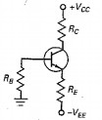
Draw the circuit diagram of two supply emitter bias of a transistor . Explain its working.
Sometimes electronic equipment has a power supply that produces both +ve and –ve supply voltages. The –ve supply forward biases the emitter diode. The +ve supply reverse bias the collector diode.
This circuit is derived from emitter bias, for this reason , we refer to it as two-supply emitter bias (TSEB).

Analysis

V_{B} ≈ 0 V

Applying KVL from emitter to base loop in anticlockwise we have V_{EE} - I_{E}R_{E} - V_{BE} =0
∴ - I_{E} = (- V_{EE} + V_{BE} ) / R_{E} = (-V_{EE} + 0.7 ) / R_{E}

∴ I_{E} = (V_{EE} - 0.7 ) / R_{E} V(RE)= VEE - 0.7 V
Applying KVL on collector side we have

- VCC+ ICRC + VC= 0

∴ VC = VCC- ICRC VCE= VC - VE

Q.7. Compare Fixed bias, Collector to base bias & Voltage divider bias circuits.

Sr.  No. | Parameter | Fixed bias | Collector to base bias | Voltage divider bias
1. | Emitter  Resistance | Not used | Not used | Used
2. | -ve Feedback | Not used | Included | Included
3. | Stability | S= (1+ β) | S = (1+ β)/ [1+ | S=(1+ β ) * [ 1+ ^{𝑅𝐵} ] /  𝑅𝐶

 | factor |  | β( ^{𝑅𝐶} )]  𝑅𝐶+𝑅𝐵 | [1+ β +^{𝑅𝐵} ]  𝑅𝐶
4. | Q-Point  stability | Poor | Moderate | Good
5. | Configuration | 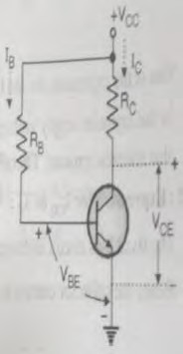 |  | 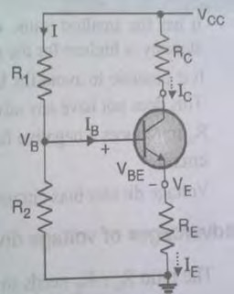

Numerical

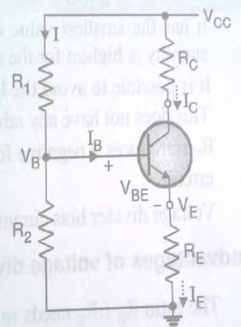
Determine I_{C}, V_{E}, V_{B}& V_{C} for the voltage divider configuration .If β=20, R₁= 62KΩ, R₂= 9.1 KΩ , R_{C}= 3.9 KΩ
,R_{E}= 0.68 KΩ &V_{CC}= 16V
Exp: As the biasing is voltage divider We have V_{B}= V_{CC}. R₂/ (R₁+R₂)
∴ V = 16 x ^{9.1𝑘Ω} = 2V
B 62𝑘Ω+9.1𝑘Ω
∵ V_{E}= V_{B}- V_{BE}
∴ V_{E}= 2V -0.7V = 1.3V
∵I_{E}= V_{E}/ R_{E}
∴I_{E}= 1.3V/ 0.68KΩ = 1.23mA
∵ I_{C}= α .I_{E}= β /(β+1) I_{E}
∴ I_{C}= 1.23mA x 20/21 = 1.17mA

For the fixed bias circuit determine I_{B}, I_{C}, V_{CE}, V_{B}, V_{C}&V_{BC} for the following parameters R_{B} = 240 KΩ , R_{C}= 2.2 KΩ , V_{CC}= 12 V & β=50
Exp: As it is fixed bias
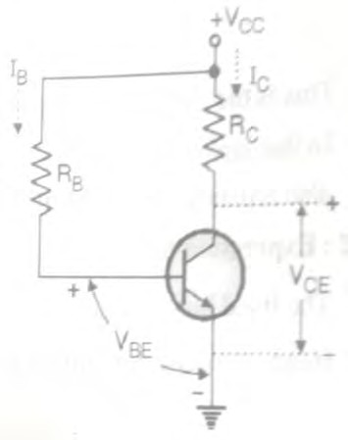
We have I_{B} = (V_{CC} – V_{BE})/ R_{B}
∴ IB= (12-0.7)/ 240 KΩ
= 47.08μA
∵I_{C}= β I_{B}
∴ I_{C}= 50 x 47.08μA = 2.35mA
∵V_{CE} = V_{CC}- I_{C}R_{C}
∴V_{CE} = 12 – 2.35mA x 2.2 KΩ
= 6.83 V
∵ Emitter terminal is grounded
∴ V_{B}= V_{BE}= 0.7V V_{C} = V_{CE}= 6.83 V
∵V_{BC}= V_{B}- V_{C}

∴V_{BC}= 0.7V – 6.83V = 6.13 V

Determine the values of I_{C} & V_{CE} for the biasing circuit shown in fig.
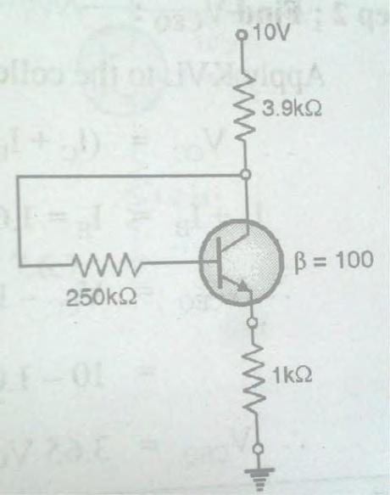
Exp: As per the given parameters in Collector-emitter feedback Applying KVL on input side, we have
-10 + 3.9kΩ(I_{C} + I_{B}) + 250kΩ. I_{B} +V_{BE}+ 1 kΩ. I_{E} = 0

∵ I_{E} = (1+β)I_{B} , I_{C} = βI_{B} ,V_{BE}=0.7 and β= 100

∴ -10 + 3.9kΩ(βI_{B} + I_{B}) + 250kΩ. I_{B} + 0.7+ 1 kΩ. (1+β)I_{B} = 0 I_{B}= 9.3/ [3.9kΩ(1+β) + 250kΩ +1 kΩ (1+β)]
I_{B}= 9.3/ [3.9kΩ(1+100) + 250kΩ +1 kΩ (1+100)] I_{B}= 12.48 μA Ans

Determine the voltage gain of a single stage CE transistor if the effective resistance of collector circuit is 2kΩ , input resistance is 1kΩ & current gain is 50. [Important]
Exp: Given R_{C}= 2kΩ , R_{in}= 1kΩ & β= A_{i}= 50

∵ A_{V}

∴ A_{V}
= β 𝑅𝐿
𝑅𝑖𝑛

= 50 * ^{2kΩ} = 100 Ans
1kΩ

Determine V_{C} and V_{B} for the network of Fig.

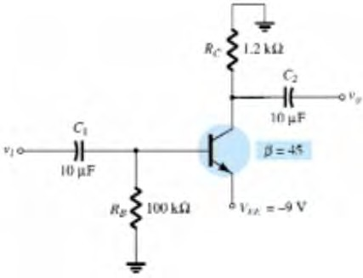
Exp: Applying KVL in the anticlockwise for the base-emitter loop , we have
+V_{EE} – V_{BE} – I_{B}R_{B}= 0

∴ I_{B}= (V_{EE} – V_{BE} )/ R_{B}

∴ I_{B}= (9-0.7)/ 100 kΩ = 83μA

∵ I_{C} = β I_{B}

∴ I_{C}= 45 x 83μA = 3.735 mA

∵V_{C}= - I_{C} R_{C}

∴VC = - 3.735 mA x 1.2 kΩ = -4.48 V

∵V_{B}= - I_{B} R_{B}

∴VC = -83mA x 100 kΩ = -8.3 V

Determine the voltage V_{CB} and the current I_{B} for the common-base configuration for the given fig.
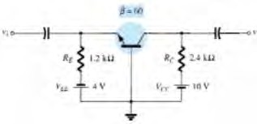
Exp: Applying KVL to the input circuit yields

-V_{EE}+ I_{E}R_{E}+ V_{BE}= 0

∴I_{E} = (V_{EE} - V_{BE}) / R_{E}= (4-0.7)/ 1.2k Ω = 2.75mA

Applying KVL to the output circuit yields

-V_{CC}+ I_{C}R_{C}+ V_{CB}= 0

∴ V_{CB} = V_{CC}- I_{C}R_{C}

∵ I_{C}≈ I_{E}

∴ V_{CB} = 10 - 2.75mA x 24 k Ω = 3.4V

∵ I_{B}= I_{C}/ β

∴ I_{B}= 2.75mA/ 60 = 45.8μA Ans

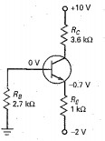
What is the collector voltage in the given circuit

Exp: Applying KVL at the Emitter base terminal we have

+ 2V – 1k Ω x I_{E} – V_{BE}= 0

∴ I_{E} = ( 2- 0.7 ) / 1k Ω = 1.3mA

∵ VC= VCC - ICRC
Also I_{C}≈ I_{E}

∴ VC= 10- 1.3mA x 3.6k Ω

5.32 V Ans

